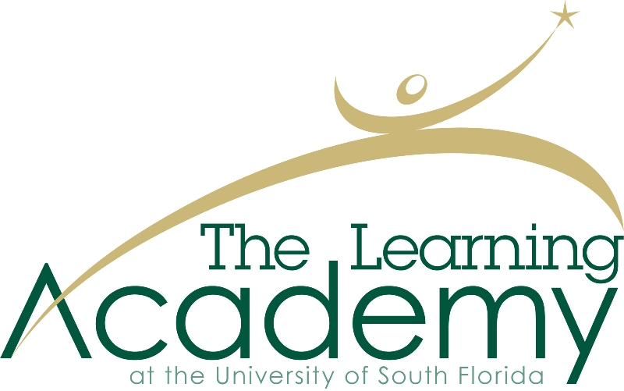

Student Application

Please complete on or before Feb. 1.
Printable applications are available upon request.

Learning Academy PROGRAM DESCRIPTION
The Learning Academy at the University of South Florida is a thirty week, transitional program designed to help students on the autism spectrum achieve a life of opportunity, independence and success. Students who are interested in seeking employment and students interested in continuing their education are eligible to apply. The intent of the program is to build and enhance skills that will prepare students for the world of work or to further their education in a college or university setting. The curriculum is structured to prepare students for the future in a challenging environment, with the provision of support and services that will facilitate success and provide the building blocks for future goal attainment. Skill development in the areas of self-knowledge, organization, time management, goal setting, conflict resolution and community contribution are emphasized for all students. The program operates on the campus of USF in Tampa.

LEARNING ACADEMY ELIGIBILITY REQUIREMENTS:
- Completed high school and is between age 18-25
- A diagnosis of an Autism Spectrum Disorder
- Reliable transportation to and from USF campus
- Use of a functional communication system
- Independent in personal self-care
- Demonstrates a clear desire to work or attend college and can commit to a 30 week program
- Demonstrates the ability to regulate his/her behavior with minimal directions within public settings

APPLICATION PROCEDURES

APPLICATIONS ARE DUE ON OR BEFORE FEB 1 FOR THE PROGRAM YEAR BEGINNING THE FOLLOWING AUGUST. APPLICATIONS RECEIVED BY THIS DATE WILL BE GUARANTEED AN INTERVIEW.

APPLICATION PACKAGES MUST BE COMPLETE TO BE CONSIDERED. A COMPLETE APPLICATION PACKAGE INCLUDES:

- Completed, signed, Learning Academy at USF Application Form
- A completed letter of recommendation from someone other than a relative – Form included
- Documentation of a qualifying diagnosis of an Autism Spectrum Disorder
- A signed Parent/Guardian Agreement Form – Form included

  - Students should complete the application as independently as possible.
  - Applications can be typed or printed neatly.

You will receive a letter or email to confirm that we received your application. Please do not call about the status of your application, as we will not be able to provide that information over the phone.

Selected applicants and their parent/caregiver will be asked to complete a personal interview.

Application

Name____________________________________ Date of Birth
Address
City_________________________________ State ______ Zip
Telephone (day)
Telephone (evening, cell, work, etc.)
Applicant email
Parent/Guardian email

1. Tell us a little bit about yourself: (Please attach additional paper if needed.)

a) With whom do you live (self, family, friends, residential program)?

b) What do you do during the day (working, going to school, day program, etc.?

c) What activities, hobbies and/or groups do you belong to or participate in?

d) Do you receive any supports or services from other agencies or professionals?
If so, please list the agency and type of service or support:

e) Are you a client of Florida Vocational Rehabilitation Services? If so, please list the name, phone number, and email address of your Vocational Rehabilitation Counselor:

2. Why you are interested in attending the Learning Academy at USF?

a) Describe something you would like to change or improve in your life.

b) Do you have a job or career goal?

c) List three careers that you are interested in or could see yourself doing:
- _____________________________
- _____________________________
- _____________________________
- Tell us how we can support you to participate in the Learning Academy. Are there specific accommodations (for example: physical accessibility, interpreters, assistive technology, etc.) you will need to fully participate?

- Is there any other specific information about yourself that you would like to share?

- Did you receive help in completing this application?

By signing this application I agree to the following if I am accepted into the Learning Academy:
- To complete all course work, homework, and activities required.
- To attend all scheduled classes, activities, and internship requirements unless there is an excused absence from the Learning Academy instructor.
- To complete follow up and reporting activities and recommendations upon graduation from the program.

Applicant’s signature _______________________________________________

Date: _____________________________________________________________

PERSONAL RECOMMENDATION LETTER

Name of Applicant:

Your Name:

Address:

City, State, Zip:

Phone Number:

Alternate Phone Number:

Email Address:

Relationship to the Applicant:

I have known the applicant for (specify years/months):

Please use a separate piece of paper to discuss the following:
1. Describe your relationship with the applicant.
2. Describe why you feel the applicant would benefit from the Learning Academy. Please refer to our website for more information about the Learning Academy. http://learningacademy.fmhi.usf.edu
3. Describe the applicant’s desire to learn, using examples from your relationship.

This letter should be no more than one (1) page in length. Return this sheet and the letter in a sealed envelope to the applicant, who must enclose it in his/her application package.

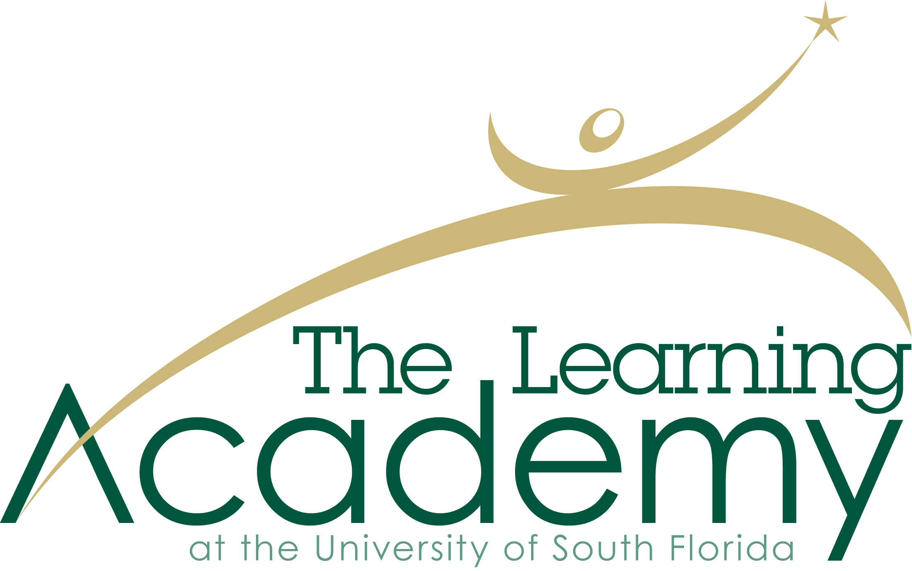

Parent/Guardian Agreement Form

As a part of the application process for USF’s Learning Academy, and to ensure successful student outcomes, we encourage family support and involvement. We ask that you review the following information and sign this agreement in support of your family member’s participation in the Learning Academy.

- My family member will be involved in making all decisions about his/her participation and follow through with the Learning Academy program.
- I will ensure my family member has reliable transportation to the Learning Academy each day to minimize absences.
- The Learning Academy includes both classroom time as well as application time with USF student mentors. Students attending this program are expected to complete all hours associated with the program.
- I understand that an internship of four or more hours a week during the last 15 weeks are a required component of the Learning Academy and that site selection will be based on the student’s identified interest.
- Personal/medical appointments for my family member shall be scheduled when the Learning Academy is not in session (late afternoon or on Fridays).
- I understand that billing will occur prior to the start of the Learning Academy and payment will be expected within 30 days of billing. No student will be allowed to participate without tuition being paid in full by the Department of Vocational Rehabilitation or by private pay.
- I understand that should my family member withdraw from the Learning Academy that no refund will be available.
- I understand that more than four absences per semester for any reason will result in dismissal from the Learning Academy.
- I understand that students of the Learning Academy are not supervised during times when class is not in session or when they are not with their mentor.
- I understand that I will not be permitted to accompany my family member during Learning Academy classes or mentoring activities.
- I agree to participate in parent workshops to support the goals and activities of the Learning Academy curriculum.

Name___________________________________

Signature________________________________

